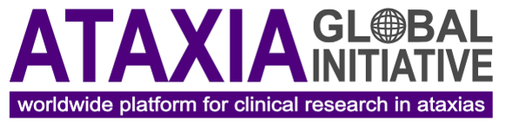

Ataxia Global Conference 2022 | Abstract submission form
4 & 5 November 2022
Dallas, TX, USA

Please send this form to ataxiaglobaloffice@med.uni-tuebingen.de. Deadline: 13 June 2022.

Authors
List abstract authors (use numbers to indicate affiliation)
e.g. Birte Zurek¹, Holm Graessner², etc.

Author affiliation
List author affiliations
e.g. 1. Affiliation A, 2. Affiliation B, etc.

Presenting author
List presenter’s name (first name last name, email address)
e.g. Birte Zurek, communication@ern-rnd.eu

Abstract topic
☐ Cohorts & natural history studies
☐ Clinical and patient-related outcomes
☐ Biomarkers (e.g. digital, fluid, MRI)
☐ Therapy development
☐ Other topic relevant for trial-readiness

Presentation preferences
Would you like to be considered for an oral presentation?
☐ Yes
☐ Yes, and I would also like to present a poster
☐ No, I would like to present my abstract as a poster

Abstract
Use max. 2500 characters incl. spaces for the abstract text

